**Satellite Data & Satellite Products in WIS Portals**

**GISC Bejing**: [http://wisportal.cma.gov.cn](http://http://wisportal.cma.gov.cn)

***Metadata directory***

*CMACast → EUMETSAT → Meteosat 0-Deg service*

*→ Meteosat 57.5-Deg service*

*→ Third-party GEO Service*

*→ Metop*

*→ NOAA-19*

*→ JASON*

*→ Satellite → FY2D*

*→ FY2E*

*→ Multi-satellite*

*Centers → CMA-DCPC →* [*DCPC NSMC*](http://wisportal.cma.gov.cn/wis/jsp/DataQuery/queryTreeItem.dhcc?treeWhere=where%20LEVEL_1=!Centres!%20and%20LEVEL_2=!CMA-DCPC!%20and%20LEVEL_3=!DCPC%20NSMC!&catalog=%3ECentres%3ECMA-DCPC%3EDCPC%20NSMC&sSQL=0&levelNum=4&flag=4) *→ FY3B*

*→ FY2E*

*→ FY3C*

*→* [*DWD*](http://wisportal.cma.gov.cn/wis/jsp/DataQuery/queryTreeItem.dhcc?treeWhere=where%20LEVEL_1=!Centres!%20and%20LEVEL_2=!DWD!&catalog=%3ECentres%3EDWD&flag=5)

*→* [*HKO*](http://wisportal.cma.gov.cn/wis/jsp/DataQuery/queryTreeItem.dhcc?treeWhere=where%20LEVEL_1=!Centres!%20and%20LEVEL_2=!DWD!&catalog=%3ECentres%3EDWD&flag=5)

*→* [*JMA*](http://wisportal.cma.gov.cn/wis/jsp/DataQuery/queryTreeItem.dhcc?treeWhere=where%20LEVEL_1=!Centres!%20and%20LEVEL_2=!DWD!&catalog=%3ECentres%3EDWD&flag=5)

*→* [*DCPC EUMETSAT*](http://wisportal.cma.gov.cn/wis/jsp/DataQuery/queryTreeItem.dhcc?treeWhere=where%20LEVEL_1=!Centres!%20and%20LEVEL_2=!DCPC%20EUMETSAT!&catalog=%3ECentres%3EDCPC%20EUMETSAT&flag=5)

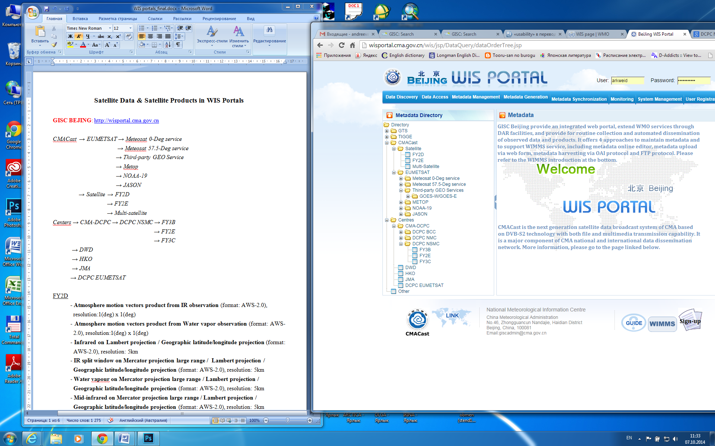

*Figure 1. Beijing WIS Portal (Metadata directory)*

***Metadata search***

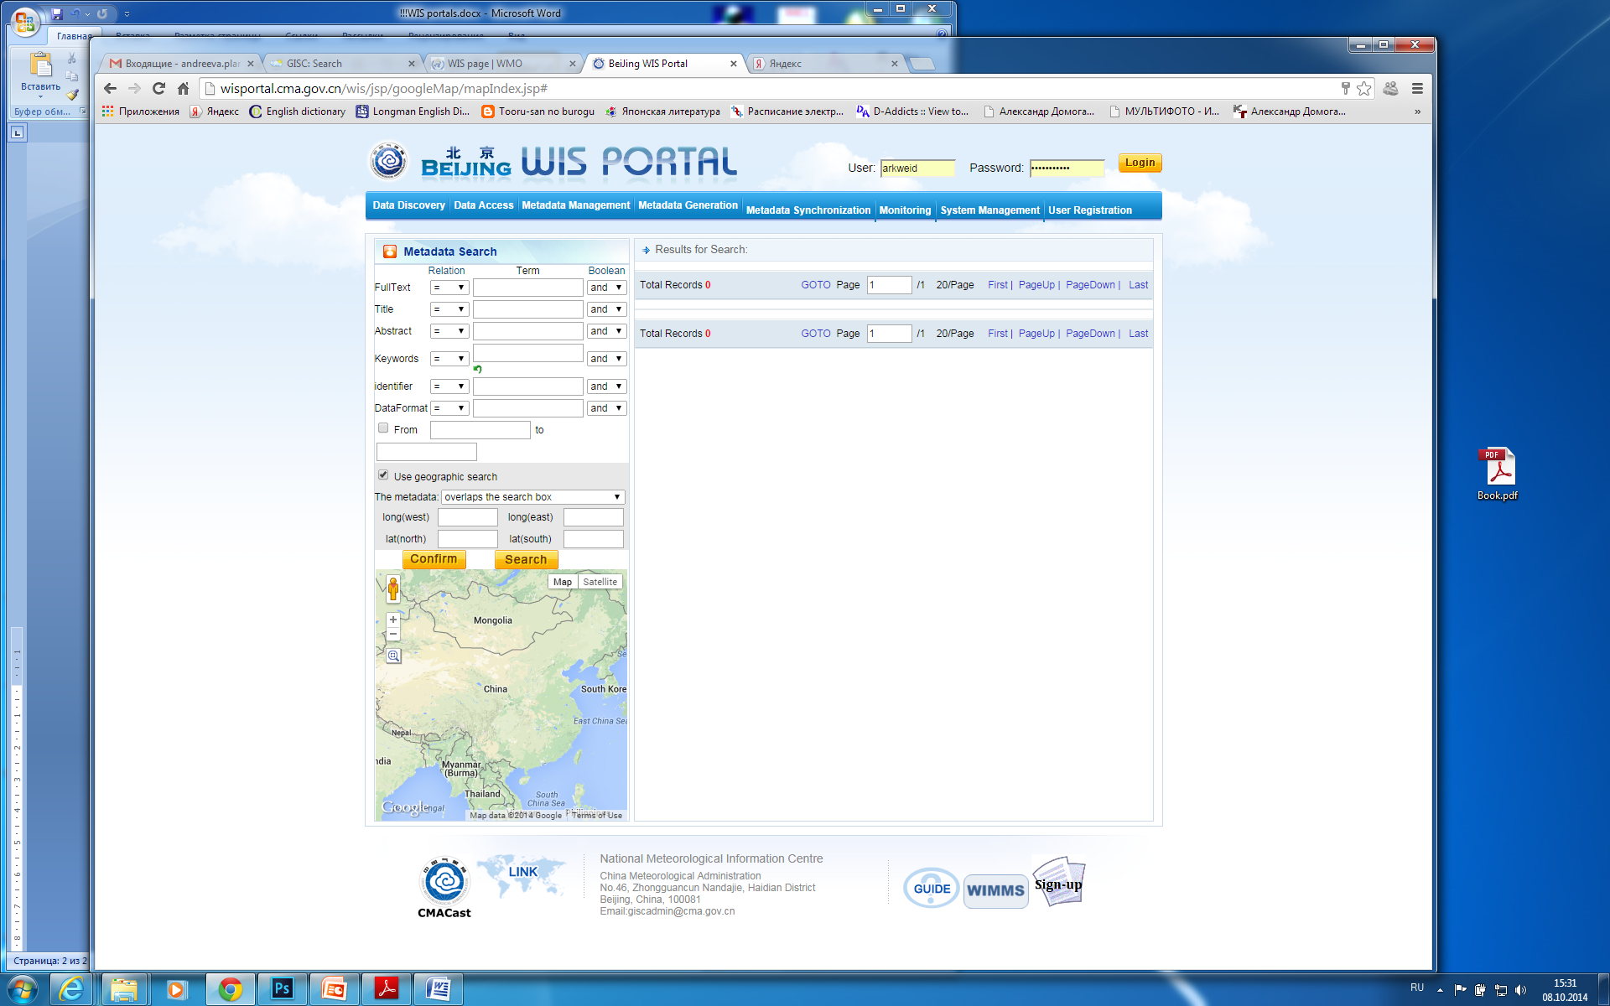

*Figure 2. Beijing WIS Portal (Metadata search)*

[FY2D](http://wisportal.cma.gov.cn/wis/jsp/DataQuery/queryTreeItem.dhcc?treeWhere=where%20LEVEL_1=!CMACast!%20and%20LEVEL_2=!EUMETSAT!%20and%20LEVEL_3=!Meteosat%200-Deg%20service!&catalog=%3ECMACast%3EEUMETSAT%3EMeteosat%200-Deg%20service&sSQL=0&levelNum=4&flag=4)

**- Atmosphere motion vectors product from IR observation** (format: AWS-2.0), resolution:1(deg) x 1(deg)

- **Atmosphere motion vectors product from Water vapor observation** (format: AWS- 2.0), resolution:1(deg) x 1(deg)

- **Infrared on Lambert projection / Geographic latitude/longitude projection** (format: AWS-2.0), resolution: 5km

- **IR split window on Mercator projection large range / Lambert projection / Geographic latitude/longitude projection** (format: AWS-2.0), resolution: 5km

- **Water vapour on Mercator projection large range / Lambert projection / Geographic latitude/longitude projection** (format: AWS-2.0), resolution: 5km

- **Mid-infrared on Mercator projection large range / Lambert projection /** **Geographic latitude/longitude projection** (format: AWS-2.0), resolution: 5km

- **Visible on Mercator projection large range / Lambert projection / Geographic latitude/longitude projection** (format: AWS-2.0), resolution: 5km

- **Visible on High resolution** (format: AWS-2.0), resolution: 1.25km

- **Cloud total amount** (format: AWS-2.0), resolution: 5km

- **Dust storm on High resolution** (format: AWS-2.0), resolution: 5km

- **Humidity profile derived from cloud analysis** (format: AWS-2.0), resolution: 4km

- **Level 1 multi-channel Stretched VISSR data** (format: BINARY), resolution: 5km

- **Normalized Geostationary Projection VISSR data** (format: HDF), resolution: 5km

- **Outgoing long-wave radiation product** (format: AWS-2.0), resolution:

0.1(deg) x 0.1(deg)

- **Daily / 5-day / 10-day / Monthly mean Outgoing long-wave radiation product** (format: AWS-2.0), resolution 0.1(deg) х 0.1(deg)

- **Precipitation estimation product** (format: AWS-2.0), resolution: 5km

**- Daily mean Precipitation estimation product** (format: AWS-2.0), resolution: 5km

- **Daily mean Surface incoming solar radiation product** (format: AWS-2.0), resolution: 1(deg) x 1(deg)

- **Daily mean Sea surface temperature product** (format: AWS-2.0), resolution:

0.5(deg) x 0.5(deg)

- **Daily / 5-day / 10-day / Monthly mean black body temperature product** (format: AWS-2.0), resolution: 0.1(deg) x 0.1(deg)

**- Daily mean Snow cover product** (format: AWS-2.0), resolution: 0.5(deg) x 0.5(deg)

- **Water vapor content at upper and middle troposphere** (format: AWS-2.0), resolution: 0.1(deg) x 0.1(deg)

[FY2E](http://wisportal.cma.gov.cn/wis/jsp/DataQuery/queryTreeItem.dhcc?treeWhere=where%20LEVEL_1=!CMACast!%20and%20LEVEL_2=!EUMETSAT!%20and%20LEVEL_3=!Meteosat%200-Deg%20service!&catalog=%3ECMACast%3EEUMETSAT%3EMeteosat%200-Deg%20service&sSQL=0&levelNum=4&flag=4)

**- Atmosphere motion vectors product** (format: AWS-2.0), resolution:1(deg) x 1(deg)

- **Infrared on Mercator projection large range / Lambert projection / Geographic latitude/longitude projection** (format: AWS-2.0), resolution:5km

- **IR split window on Mercator projection large range /** **Lambert projection / Geographic latitude/longitude projection** (format: AWS-2.0), resolution:5km

- **Water vapour on Mercator projection large range / Lambert projection / Geographic latitude/longitude projection** (format: AWS-2.0), resolution:5km

- **Mid-infrared on Lambert projection / Geographic latitude/longitude projection** (format: AWS-2.0), resolution:5km

- **Visible on Mercator projection large range / Lambert projection / Geographic latitude/longitude projection** (format: AWS-2.0), resolution:5km

- **Visible on High resolution** (format: AWS-2.0), resolution:1.25km

- **Cloud physical parameters product** (format: AWS-2.0), resolution:

0.1(deg) x 0.1(deg)

- **Humidity product** (format: AWS-2.0), resolution:0.1(deg) x 0.1(deg)

- **Level 1 multi-channel Stretched VISSR data** (format: BINARY), resolution:5km

- **Normalized Geostationary Projection VISSR data** (format: HDF), resolution:5km

- **Outgoing long-wave radiation product** (format: AWS-2.0), resolution:

0.1(deg) x 0.1(deg)

- **Daily / 5-day / 10-day / Monthly mean Outgoing long-wave radiation product** (format: AWS-2.0), resolution: 0.1(deg) x 0.1(deg)

- **Precipitation estimation product** (format: AWS-2.0), resolution: 0.1(deg) x 0.1(deg)

- **Daily mean Precipitation estimation product** (format: AWS-2.0), resolution:

0.1(deg) x 0.1(deg)

- **Infrared on Mercator projection large range / Lambert projection** (format: AWS- 2.0), resolution:15km / 13km

- **IR split window on Mercator projection large range /** **Lambert projection** (format: AWS-2.0), resolution:15km / 13km

- **Water vapour on Mercator projection large range / Lambert projection** (format: AWS-2.0), resolution:15km / 13km

- **Mid-infrared on Mercator projection large range / Lambert projection** (format: AWS-2.0), resolution:15km / 13km

- **Visible on Mercator projection large range / Lambert projection** (format: AWS- 2.0), resolution:15km / 13km

- **Monitoring Image for soil humidity** (format: AWS-2.0), resolution:5km

- **Daily mean Surface incoming solar radiation product** (format: AWS-2.0), resolution: 1(deg) x 1(deg)

- **Daily mean Sea surface temperature product** (format: AWS-2.0), resolution:

0.1(deg) x 0.1(deg)

- **Daily / 5-day / 10-day / Monthly mean black body temperature product** (format: AWS-2.0), resolution: 0.1(deg) x 0.1(deg)

**- Daily mean Snow cover product** (format: AWS-2.0), resolution: 0.1(deg) x 0.1(deg)

[Multi-Satellite](http://wisportal.cma.gov.cn/wis/jsp/DataQuery/queryTreeItem.dhcc?treeWhere=where%20LEVEL_1=!CMACast!%20and%20LEVEL_2=!Satellite!%20and%20LEVEL_3=!Multi-Satellite!&catalog=%3ECMACast%3ESatellite%3EMulti-Satellite&flag=5)

- **Animated graphics product sources of FY2D and FY2E satellite IR observation** (format: AWS-2.0)

- **Analysis product for storm monitoring in China territory from CMA FY2 satellite** (format: AWS-2.0), resolution:1km

- **Analysis product for monitoring China south-sea monsoonor of FY2 satellite** (format: AWS-2.0), resolution:1km

- **Monitoring image for sea ice of FY2 satellite** (format: AWS-2.0), resolution:5km

- **Analysis image for monitoring northeast pacific coding tropical cyclones of FY2** **satellite** (format: AWS-2.0), resolution:5km

- **Monitoring image for fire of FY2 satellite** (format: AWS-2.0)

- **Monitoring Image for fog of FY2 satellite** (format: AWS-2.0)

[Meteosat 0-Deg service](http://wisportal.cma.gov.cn/wis/jsp/DataQuery/queryTreeItem.dhcc?treeWhere=where%20LEVEL_1=!CMACast!%20and%20LEVEL_2=!EUMETSAT!%20and%20LEVEL_3=!Meteosat%200-Deg%20service!&catalog=%3ECMACast%3EEUMETSAT%3EMeteosat%200-Deg%20service&sSQL=0&levelNum=4&flag=4)

[0-Deg Meteosat SEVIRI Level 1.5 Image Data](http://wisportal.cma.gov.cn/wis/jsp/DataQuery/queryTreeItem.dhcc?treeWhere=where%20LEVEL_1=!CMACast!%20and%20LEVEL_2=!EUMETSAT!%20and%20LEVEL_3=!Meteosat%200-Deg%20service!%20and%20LEVEL_4=!0-Deg%20SEVIRI%20Level%201.5%20Image%20Data!&catalog=%3ECMACast%3EEUMETSAT%3EMeteosat%200-Deg%20service%3E0-Deg%20SEVIRI%20Level%201.5%20Image%20Data&sSQL=0&levelNum=5&flag=4) (frequency – 1h & 3h)

0-Deg Meteosat Meteorological Products

- **Aerosol Properties over Sea**, AES (daily averaged product)

- **Airmass product is an RGB**, [AIRMASS](http://wisportal.cma.gov.cn/wis/jsp/DataQuery/queryTreeItem.dhcc?treeWhere=where%20LEVEL_1=!CMACast!%20and%20LEVEL_2=!EUMETSAT!%20and%20LEVEL_3=!Meteosat%200-Deg%20service!%20and%20LEVEL_4=!0-Deg%20Meteosat%20Meteorological%20Products!&catalog=%3ECMACast%3EEUMETSAT%3EMeteosat%200-Deg%20service%3E0-Deg%20Meteosat%20Meteorological%20Products&flag=5) (frequency – 1h)

- **Atmospheric Motion Vectors**, AMV (frequency – 1h)

- **All Sky Radiances**, ASR (frequency – 1h)

- **Climate Data Set**, CDS (frequency – 30min)

- **Cloud Analysis**, CLA (frequency – 3h)

- **Cloud Analysis Image**, CLAI (frequency – 3h)

- **Cloud Mask**, CLM (frequency – 15min)

- **Clear-Sky Reflectance Map**, CRM (daily averaged product)

- **Cloud Top Height**, CTH (frequency – 15min)

- **Divergence Product**, DIV (frequency – 1h)

- **Day Microphysics RGB**, [DMRGB](http://wisportal.cma.gov.cn/wis/jsp/DataQuery/queryTreeItem.dhcc?treeWhere=where%20LEVEL_1=!CMACast!%20and%20LEVEL_2=!EUMETSAT!%20and%20LEVEL_3=!Meteosat%200-Deg%20service!%20and%20LEVEL_4=!0-Deg%20Meteosat%20Meteorological%20Products!&catalog=%3ECMACast%3EEUMETSAT%3EMeteosat%200-Deg%20service%3E0-Deg%20Meteosat%20Meteorological%20Products&flag=5) (frequency – 1h)

- **Dust RGB**, DUST (frequency – 1h)

- **Evapotranspiration**, ET (frequency – 30 min)

- **Active Fire Monitoring**, FIR (frequency – 15min): formats GRIB, ASCII, CAP

- **Global Instability Index**, GII (frequency – 15min)

- **High Resolution Precipitation Index**, HPI (daily averaged product)

[Meteosat 57.5-Deg service](http://wisportal.cma.gov.cn/wis/jsp/DataQuery/queryTreeItem.dhcc?treeWhere=where%20LEVEL_1=!CMACast!%20and%20LEVEL_2=!EUMETSAT!%20and%20LEVEL_3=!Meteosat%2057.5-Deg%20service!&catalog=%3ECMACast%3EEUMETSAT%3EMeteosat%2057.5-Deg%20service&sSQL=0&levelNum=4&flag=4)

[IODC High Resolution Image Data](http://wisportal.cma.gov.cn/wis/jsp/DataQuery/queryTreeItem.dhcc?treeWhere=where%20LEVEL_1=!CMACast!%20and%20LEVEL_2=!EUMETSAT!%20and%20LEVEL_3=!Meteosat%2057.5-Deg%20service!%20and%20LEVEL_4=!IODC%20High%20Resolution%20Image%20Data!&catalog=%3ECMACast%3EEUMETSAT%3EMeteosat%2057.5-Deg%20service%3EIODC%20High%20Resolution%20Image%20Data&sSQL=0&levelNum=5&flag=4) (frequency – 30min & 1h & 3h)

[IODC Meteosat Meteorological Products](http://wisportal.cma.gov.cn/wis/jsp/DataQuery/queryTreeItem.dhcc?treeWhere=where%20LEVEL_1=!CMACast!%20and%20LEVEL_2=!EUMETSAT!%20and%20LEVEL_3=!Meteosat%2057.5-Deg%20service!%20and%20LEVEL_4=!IODC%20Meteosat%20Meteorological%20Products!&catalog=%3ECMACast%3EEUMETSAT%3EMeteosat%2057.5-Deg%20service%3EIODC%20Meteosat%20Meteorological%20Products&flag=5)

- **Meteosat Surface Albedo**, MSA1 (10-day averaged product)

- **Climate Data Set**, CDS (frequency – 30min)

- **Cloud Analysis**, CLA (frequency – 3h)

- **Cloud Motion Winds**, CMW (frequency – 1.5h)

- **Clear Sky Radiances**, CSR (frequency – 1h)

- **Expanded Low-resolution Cloud Motion Winds**, ELW (frequency – 1.5h)

- **High Resolution Precipitation Index** (daily averaged product)

- **HRI Level 1.5 Image Data**, HRI (frequency – 30min)

- **High Resolution Visible Winds**, HRV (frequency – 1.5h)

- **Multi-Sensor Precipitation Estimate**, MPE (frequency – 30min): formats GRIB, JPG

- **Sea Surface Temperature**, SST (frequency – 12h)

- **Upper Tropospheric Humidity**, UTH (frequency – 1h)

[Third-party GEO Services](http://wisportal.cma.gov.cn/wis/jsp/DataQuery/queryTreeItem.dhcc?treeWhere=where%20LEVEL_1=!CMACast!%20and%20LEVEL_2=!EUMETSAT!%20and%20LEVEL_3=!Third-party%20GEO%20Services!&catalog=%3ECMACast%3EEUMETSAT%3EThird-party%20GEO%20Services&sSQL=0&levelNum=4&flag=4)

[GOES-W/GOES-E](http://wisportal.cma.gov.cn/wis/jsp/DataQuery/queryTreeItem.dhcc?treeWhere=where%20LEVEL_1=!CMACast!%20and%20LEVEL_2=!EUMETSAT!%20and%20LEVEL_3=!Third-party%20GEO%20Services!%20and%20LEVEL_4=!GOES-W/GOES-E!&catalog=%3ECMACast%3EEUMETSAT%3EThird-party%20GEO%20Services%3EGOES-W/GOES-E&sSQL=0&levelNum=5&flag=4) Image data (frequency – 30min & 1h & 3h)

[METOP](http://wisportal.cma.gov.cn/wis/jsp/DataQuery/queryTreeItem.dhcc?treeWhere=where%20LEVEL_1=!CMACast!%20and%20LEVEL_2=!EUMETSAT!%20and%20LEVEL_3=!METOP!&catalog=%3ECMACast%3EEUMETSAT%3EMETOP&sSQL=0&levelNum=4&flag=4)

Level 1

- **AMSU-A** GDS Level 1B

- **ASCAT** GDS Level 1 Sigma0 at Full Sensor Resolution

- **ASCAT** GDS Level 1 Sigma0 resampled at 25 km Swath Grid

- **ASCAT** GDS Level 1 Sigma0 resampled at 12.5 km Swath Grid

- **AVHRR** GDS Level 1B

- **GOME-2** GDS Level 1B

- **GRAS** GDS Level 1B

- **IASI** GDS Level 1C - all spectral samples

- **IASI** GDS Level 1C - reduced spectral samples

- **HIRS** GDS Level 1B

- **MHS** GDS Level 1B

Level 2

**- ASCAT Winds at 12.5 km Swath Grid**

**- ASCAT Winds at 25 km Swath Grid**

**- ATOVS Sounding Products**

**- IASI Cloud Parameters**

**- IASI Surface Emissivity**

**- IASI Ozone**

**- IASI Trace Gases**

**- IASI Atmospheric Temperature Water Vapour and Surface Skin Temperature**

[NOAA-19](http://wisportal.cma.gov.cn/wis/jsp/DataQuery/queryTreeItem.dhcc?treeWhere=where%20LEVEL_1=!CMACast!%20and%20LEVEL_2=!EUMETSAT!%20and%20LEVEL_3=!NOAA-19!&catalog=%3ECMACast%3EEUMETSAT%3ENOAA-19&sSQL=0&levelNum=4&flag=4)

Level 1

- **AMSU-A** GDS Level 1B

- **HIRS** GDS Level 1B

- **MHS** GDS Level 1B

Level 2

**- ATOVS Sounding Products**

[JASON](http://wisportal.cma.gov.cn/wis/jsp/DataQuery/queryTreeItem.dhcc?treeWhere=where%20LEVEL_1=!CMACast!%20and%20LEVEL_2=!EUMETSAT!%20and%20LEVEL_3=!JASON!%20and%20LEVEL_4=!OSDR/OGDR!&catalog=%3ECMACast%3EEUMETSAT%3EJASON%3EOSDR/OGDR&flag=5)

Operational Geophysical Data Record (netCDF): Jason-1, Jason-2

**GISC Brasilia**: <http://gisc.inmet.gov.br/gisc/start_js_JSP.do>

***Only general search (e.g. not by category, etc.) is functional*** *(see the figure 3).*

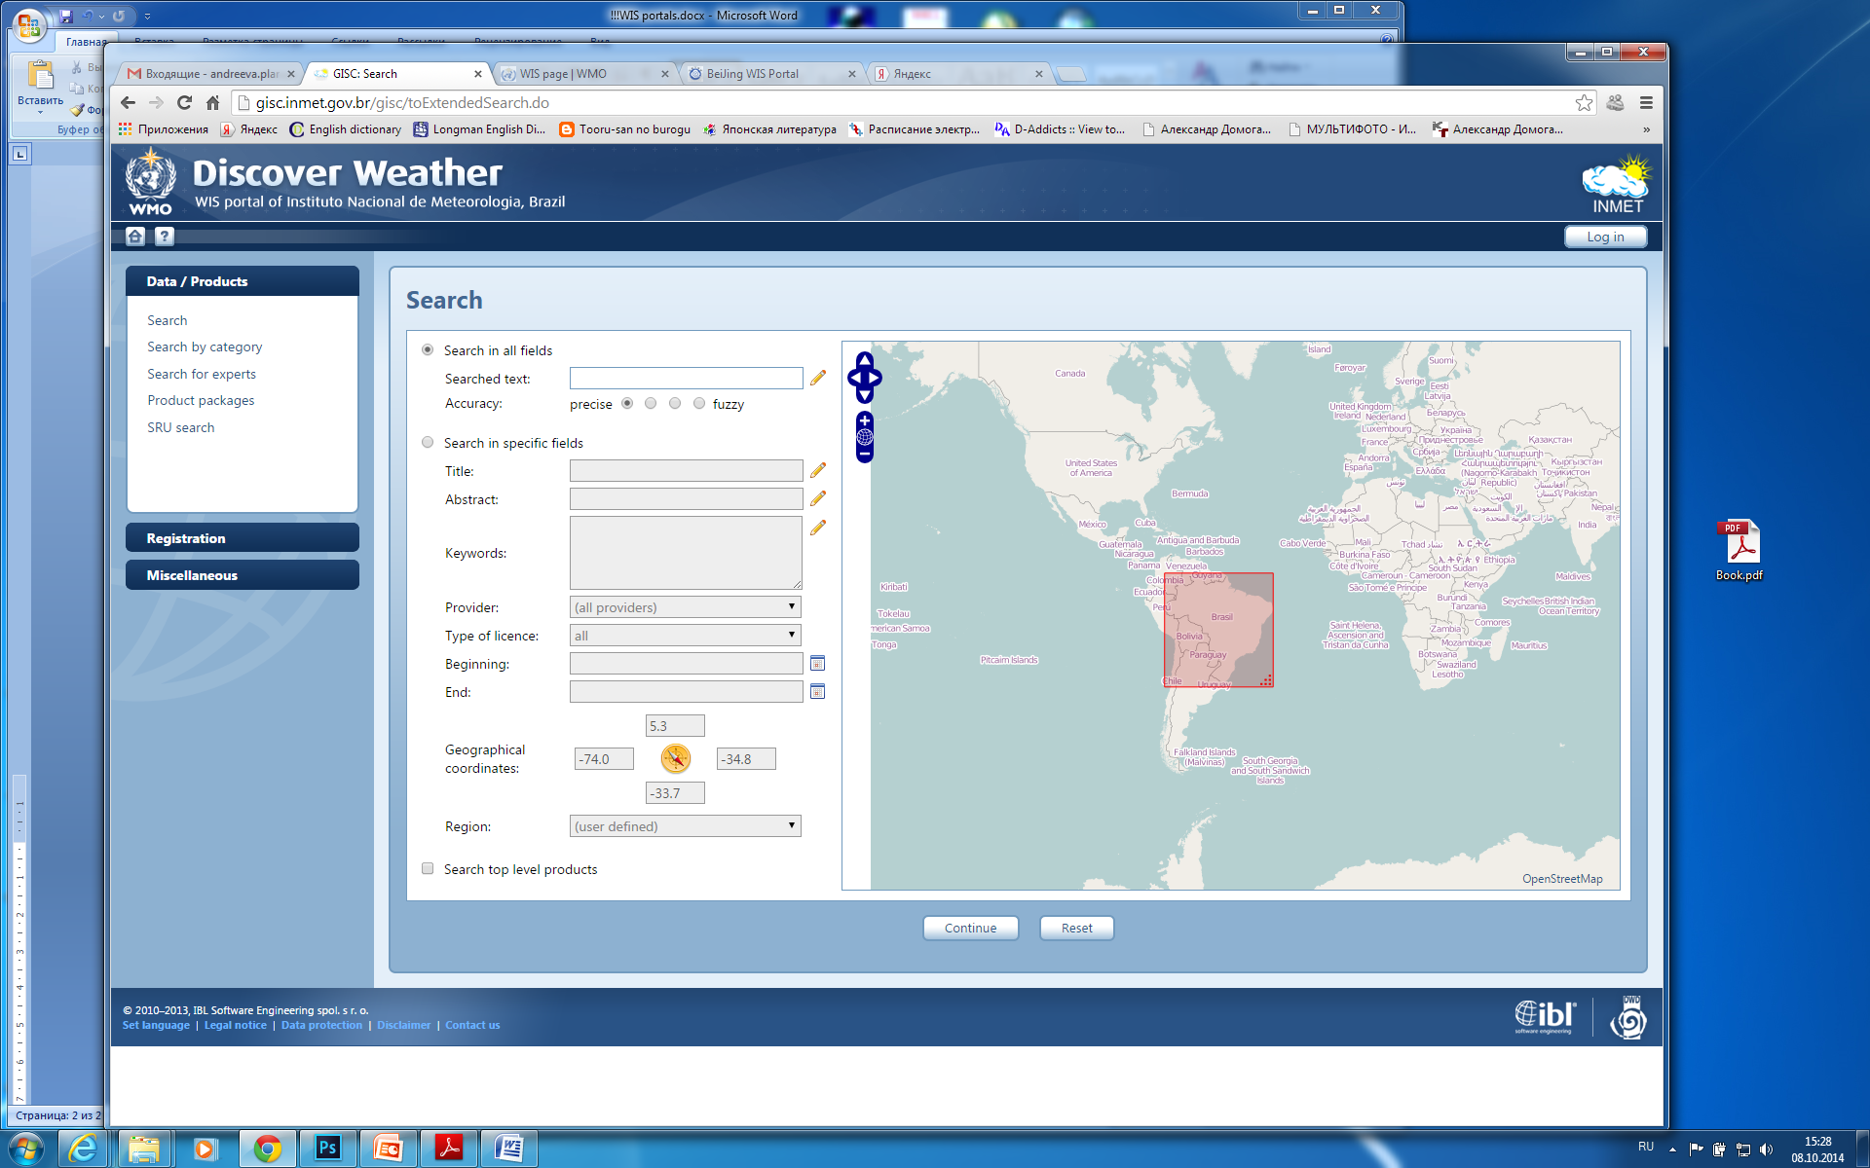

*Figure 3. Brasilia WIS Portal.*